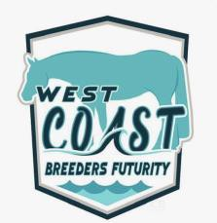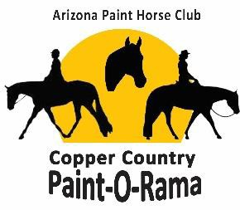

Class Name/Number___________________________________
Arizona Paint Horse Club
Copper Country POR Futurity Entry Form
Dec 29-31, 2022
Westworld, 16601 N. Pima Road, Scottsdale, AZ 85260
West Coast Breeders Futurity
Entry Fee $175 by Dec 15 / $325 after Dec 15
Classes Offered
#900 – WCBF Yearling Longe Line Non-Pro
#901 – WCBF Yearling Longe Line Open
#902 – WCBF Showmanship Non-Pro
#903 – WCBF HUS Junior Horse
#904 – WCBF HUS Non-Pro
#905 – WCBF Trail Junior Horse
#906 – WCBF Trail Non-Pro
#907 – WCBF Western Pleasure Junior Horse
#908 – WCBF Western Pleasure Non-Pro
APHC $1,000 added Elite Futurity/Maturity
Entry Fee $175 by Dec 15 / $325 after Dec 15
Classes Offered
#800 - The Gift Of Midas NSBA Yearling Longe Line
#801 – 2022 Weanling Halter Fillies, Colts, Geldings
#802 - The Gift of Midas NSBA All Age HUS
#803 - The Gift of Midas NSBA All Age Western Pleasure
Name of Horse (Exactly as shown on Registration Papers) Breed Registry Registry # Date Foaled_ Sex (Mare, Stallion, Gelding) Sire Dam Sire Reg.# Dam Reg.# Owner Exhibitor Owner Address Owner Email
Phone SSN# - -
(SSN Required)
Please enter online at www.azpaints.org or www.showofficeservices.com
Be sure to bring your Registration Papers to prove ownership at the show.
For questions or clarifications on Elite Futurities, please text or call Laurie Roden at (602) 708-8410 or email laurie@roden.com
For questions or clarifications on the West Coast Breeders Futurities please email Brandon Severin at westcoastbreedersfuturity@gmail.com

Check us out at www.azpaints.org to see rules and eligibility

